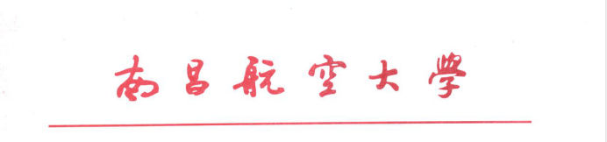

证 明
兹有XXX，性别：女，1998年12月2日出生，于2016年9月通过国家高考被录取到南昌航空大学会计专业学习,学制为四年本科，学号：16097219。若符合我校规定的毕业和学位授予条件，将于2020年6月毕业并获得学士学位，特此证明！

南昌航空大学教务处
南昌航空大学XXXXXX学院
2020年6月29日

Certificate
This is to certify that XXX, female, born on December 2nd, 1998, was enrolled to Nanchang Hangkong University for Bachelor degree study through the National Standard Test for Higher Education Enrollment in Sept. 2016. She is majoring in Accounting, a four-year undergraduate programme. The ID of the student is 16097219. The student will graduate with the diploma and the bachelor's degree in June 2020, if she meets graduation and degree granted Requirements of Nanchang Hangkong University.

Department of Educational Administration,
School of XXXXXX,
Nanchang Hangkong University
June 29th , 2020

Address: 696 Fenghe South Avenue, Nanchang, Jiangxi, P.R.China 330063
Contact: YAN Yan, Chief of Academic Management Division
Tel: +86 791 83863717 Fax: +86 791 83863779
Email: yanyan@nchu.edu.cn

